Section 2: Lumbar Region

Card ID: 2.1
Image file: L1344_760068
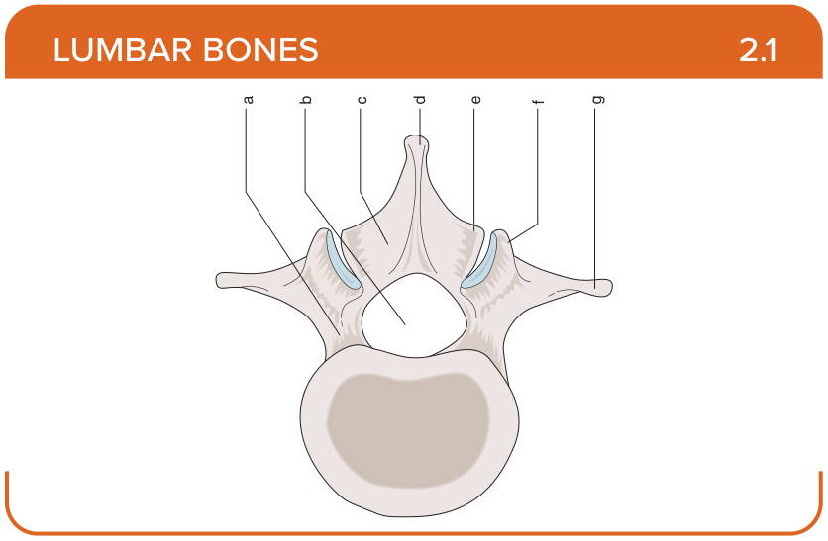
Title: Vertebra (Superior)
Activity Interaction: Drag and drop
Back-of-Card Content:
a. Pedicle
b. Vertebral canal
c. Lamina
d. Spinous process
e. Inferior articular facet
f. Superior articular facet
g. Transverse process

Card ID: 2.2
Image file: L1344_760069
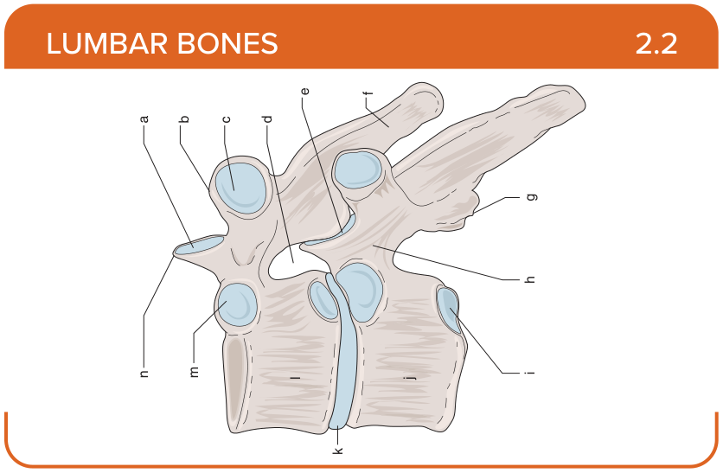
Title: Vertebra (Lateral)
Activity Interaction: Drag and drop
Back-of-Card Content:
a. Superior articular process
b. Transverse process
c. Costal facet
d. Intervertebral foramen
e. Apophyseal joint
f. Spinous process
g. Inferior articular process
h. Pedicle
i. Inferior costal facet
j. T7
k. Intervertebral disc
l. T6
m. Superior costal facet
n. Superior articular process

Card ID: 2.3
Image file: L1344_760070
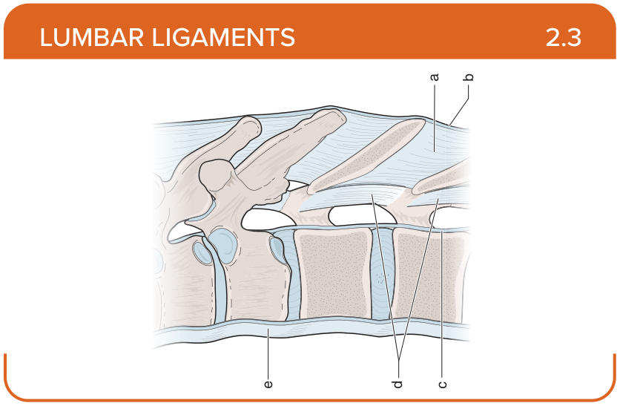
Title: Lumbar Ligaments (Lateral)
Activity Interaction: fill-in-the-blank
Back-of-Card Content:
a. Interspinous ligament: restricts hyperflexion
b. Supraspinous ligament: restricts hyperflexion and separation of the spinous processes
c. Posterior longitudinal ligament: restricts hyperflexion
d. Ligamentum flavum: restricts excessive separation of adjacent vertebral lamina and hyperflexion
e. Anterior longitudinal ligament: restricts excessive hyperextension

Card ID: 2.4
Image file: L1344_760071
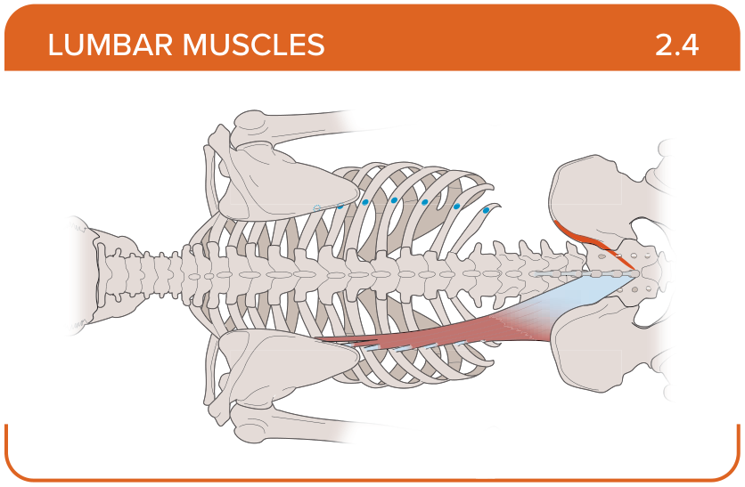
Title: Iliocostalis lumborum
Activity Interaction: select all that apply
Back-of-Card Content:
Proximal insertion:
- *posterior surface of the sacrum
- *lip of the iliac crest
- *thoracolumbar fascia
- transverse process of vertebrae
Distal insertion:
- *angle of the 6th to 12th ribs
- *transverse process of L1-L4 vertebrae
- the spinous process of the inferior vertebra

Innervation:
- *dorsal rami of spinal nerves
- posterior rami of the spinal nerves
- medial ramus of the dorsal root of the spinal nerve

Action:
- *bilateral contraction—lumbar spine extension
- *unilateral contraction—ipsilateral lumbar spine side bending
- lumbar spine stabilization

Card ID: 2.5
Image file: L1344_760072
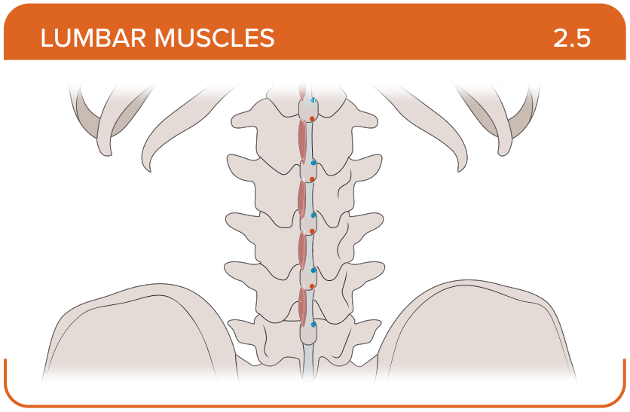
Title: Interspinales lumborum
Activity Interaction: select all that apply
Back-of-Card Content:
Proximal insertion:
- *spinous process of the superior vertebra
- thoracolumbar fascia
- transverse process of vertebrae

Distal insertion:
- *spinous process of the inferior vertebra
- transverse process of L1-L4 vertebrae
- rib 12
Innervation:
- *posterior rami of the spinal nerves
- dorsal rami of spinal nerves
- medial ramus of the dorsal root of the spinal nerve

Action:
- *lumbar spine stabilization
- bilateral contraction—lumbar spine extension
- unilateral contraction—ipsilateral lumbar spine side bending

Card ID: 2.6
Image file: L1344_760073
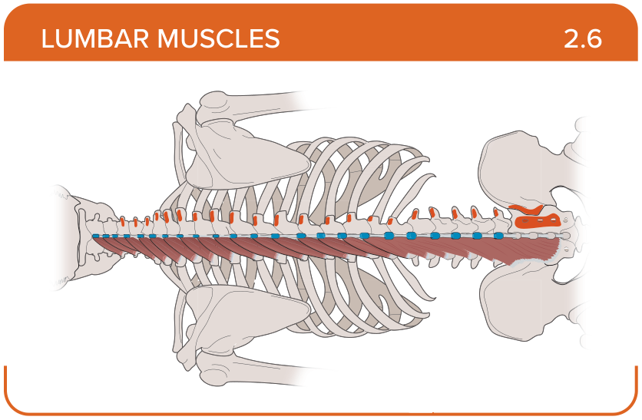
Title: Multifidus
Activity Interaction: select all that apply
Back-of-Card Content:
Proximal insertion:
- *back surface of the sacrum
- *posterior superior iliac spine
- *transverse process of vertebrae
- thoracolumbar fascia

Distal insertion:
- *base of the spinous process of vertebrae
- angle of the 6th to 12th ribs
- transverse process of L1-L4 vertebrae
- the spinous process of the inferior vertebra

Innervation:
- *medial ramus of the dorsal root of the spinal nerve
- dorsal rami of spinal nerves
- posterior rami of the spinal nerves

Action:
- *bilateral contraction—vertebral column extension
- *ipsilateral contraction—contralateral rotation of vertebral column
- bilateral contraction—vertebral column flexion
- ipsilateral contraction—ipsilateral rotation of vertebral column

Card ID: 2.7
Image file: L1344_760074
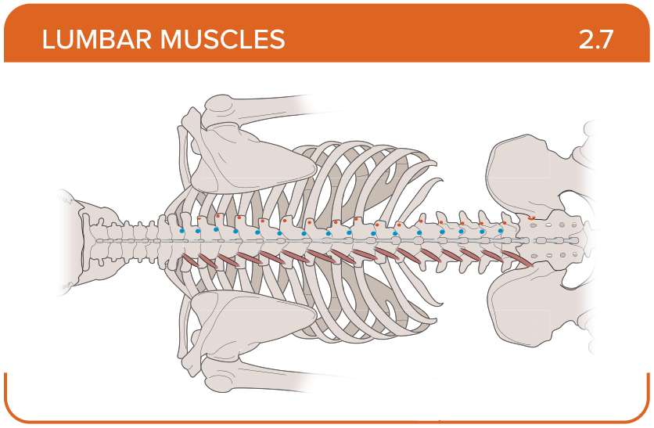
Title: Rotators
Activity Interaction: select all that apply
Back-of-Card Content:
Proximal insertion:
- *transverse process of vertebrae
- spinous process of the superior vertebra
- posterior surface of the sacrum
- thoracolumbar fascia

Distal insertion:
- *spinous process of the superior vertebrae
- transverse process of L1-L4 vertebrae
- the spinous process of the inferior vertebra

Innervation:
- *posterior rami of the spinal nerve
- dorsal rami of spinal nerves
- medial ramus of the dorsal root of the spinal nerve

Action:
- *stabilizes the spine
- *contributes to rotation and extension of the spine
- unilateral contraction—ipsilateral lumbar spine side bending

Card ID: 2.8
Image file: L1344_760075
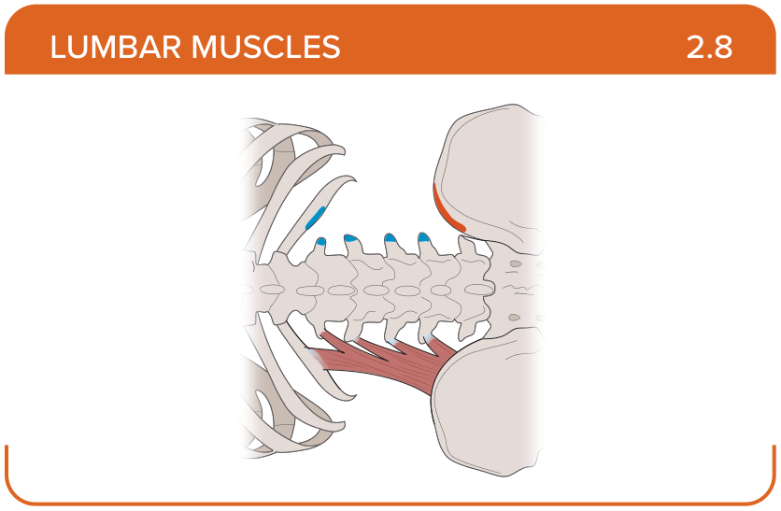
Title: Quadratus lumborum
Activity Interaction: select all that apply
Back-of-Card Content:
Proximal insertion:
- *ilium
- *ribs 5 to 10
- posterior surface of the sacrum

Distal insertion:
- *rib 12
- *vertebrae L1-L4
- angle of the 8th to 10th ribs
- posterior surface of the sacrum

Innervation:
- *subcostal nerve (T12)
- *anterior rami of spinal nerves L1-L4
- dorsal rami of spinal nerves
- posterior rami of the spinal nerves

Action:
- *lateral bending
- bilateral contraction—lumbar spine extension
- unilateral contraction—ipsilateral lumbar spine side bending
- lumbar spine stabilization

